Beecraigs East – Wednesday Evening Event 24/05/23 – Final Details
Parking: Balvormie Car Park , EH49 6PL or, the overflow car park immediately to the north.
What 3 words ///vocab.sundial.reform , grid reference: 55.9497, -3.6051
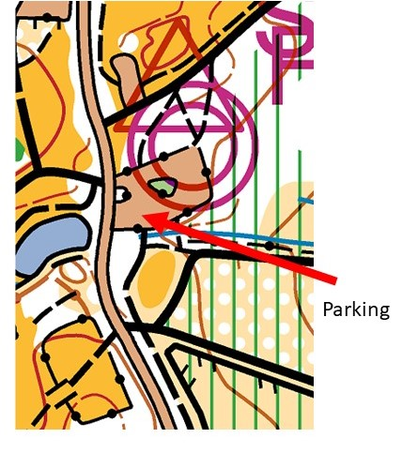
Toilets: Will not be open. Please be aware prior to travelling.
Registration/Download/SI Hire/ Start/Finish: At the picnic tables just north of carpark.
Terrain: Beecraigs East is the more managed area of the country park with lots of paths, a wooded area to the north and the loch to the east. The Yellow and Orange courses will be entirely within the woods. The Green and Short Green will cross the minor road to the north. This must be crossed with care at the marked points. You may need to run a short distance along the road when crossing to and from the northern section depending on route choice. Be careful running through car parks. The road from the visitor centre to the Lochside carpark is a forbidden route, there is a path parallel to the road if you choose this route. The Green course will also cross the road to the loch – be careful when crossing.
There is an OOB area marked on the map to the south – this is a building site.
The mountain bike route is OOB.
The camp site is always OOB.
Beecraigs is a popular area with the public, there is likely to be walkers, dog walkers or horses. Please be courteous when passing.
Map: 1:10,000 scale, 5 metre contour interval.
Control Descriptions: On the map and also available to download alongside these details.
Courses: Yellow 2k 50m climb
Orange 2.4k 50m climb
Short Green 4.1k 80m climb
Green 6k 120m climb
Courses Close: 8PM. Please ensure you finish your course or return back to download by
this time.
All participants take part at their own risk. Anyone with a pre-existing medical condition
which might affect their taking part should disclose them to the race organiser before they
start.
Please check for ticks after you have run.
Courses planned by 3 generations of Finches. Any questions or comments please speak to Simon, Ted or Esme. ted@finchhouse.org, 07980010924
Hope you have an awesome run!

