FVO Night Event – Devilla Forest – Final Details

Wednesday 21st January

Venue
Devilla Forest, east of Kincardine.

Directions / Parking
Parking is in the Devilla Forest car park (see map below), just off the A985 (Kincardine to Dunfermline Road). Please approach from the west and take care turning off the main road. Please take extra care when leaving the event car park and turning west. Link: Devilla Forest Parking - Google Maps

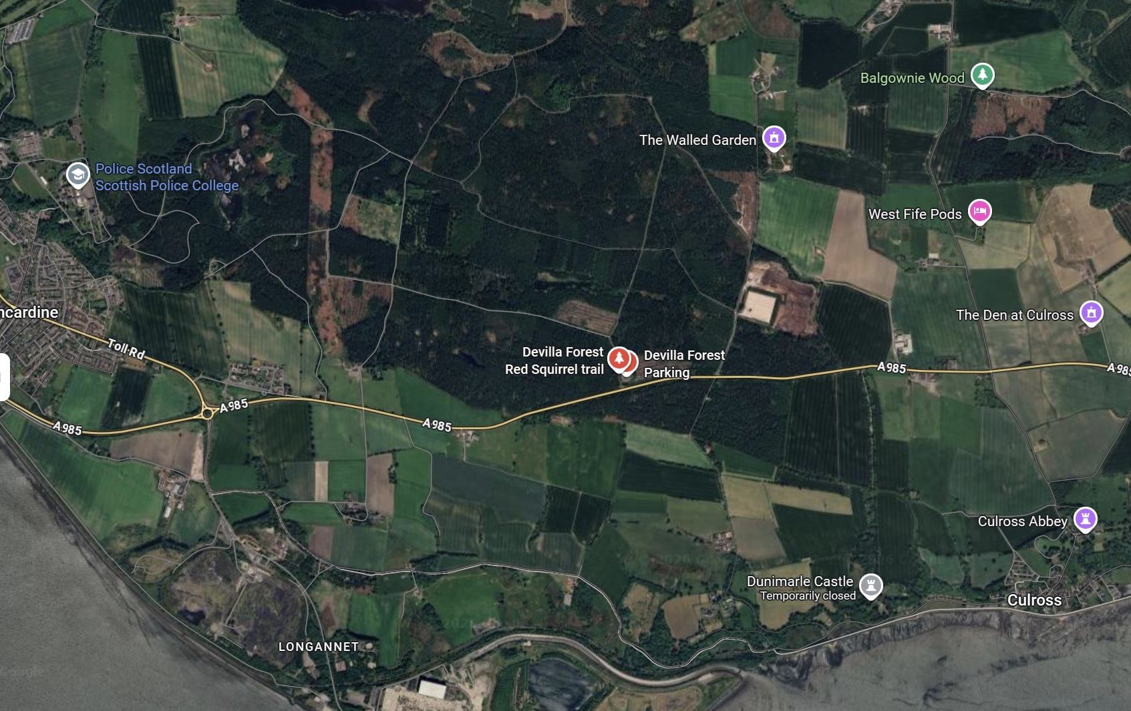

Timings
We will depart the car park at 18:30hrs sharp to “jog” to the start which is c1km north of the car park.
The pre-event briefing / roll call / SI clear and check will take place at the start. The single mass start will be at c1840hrs. Courses close at 20:00hrs, please note some furthest away controls may be collected before 20:00hrs.

Toilets
There are no public toilets at the car park, please plan accordingly.

Courses
Course | Length
Long | 5.5km
Short | 3.7km
Novice | 2.4km
Control descriptions are on the map.
Map Scale: 1: 7:500

Terrain/Planners Notes
Nice mix of terrain, the courses stay almost entirely within the runnable forest, which are interspersed with patches of open and semi-open. There has been some windblow, these are random tree’s which are not mapped and should not affect route choice.
As expected at this time of year the mashes are very wet, be careful crossing ditches and watercourses.
There are a number of unmapped small rhododendron bushes, these reduce visibility and can be easily navigated around.
Please be courteous to any other users of the area you encounter – I don’t expect there to be very many especially at night.
The finish and download are at the car park

First Aid
There will be a basic first aid kit in the assembly / car park. The nearest hospital is Forth Valley Royal Hospital, Stirling Rd, Larbert FK5 4WR
Competitors are reminded that they take part at their own risk and are responsible for their own safety.

Results
Results will be posted on the FVO website as soon as practicable after the event.

Acknowledgements
Forestry Land Scotland (access) and KFO (map)

Contacts
Organiser / Planner / Controller: Fraser Purves 07875872887

