Lochan Spling Night O Final Details
Wednesday 4th March 2026

Directions / Car Parking
Loch Ard Forest Car Park beyond Milton.
What3Words ///every.tonsils.sculpting
Google Maps:https://maps.app.goo.gl/oExmxwz7vGQTE3ab8

Please use the FVO Transport Sharing Whats app group wherever possible.

Location of registration and start procedure
Gathering will take place from 6pm at Loch Ard forest car park, with a roll call and briefing at 6:15 before a jog to the start 1km away.
Late arrivals can follow tape to the start which is located at:
GR 501 008
W3W ///vote.haven.tint

Those not wishing to take part in the mass start may instead use a punching start. Late
starts will also be punching starts. No starts will be allowed later than 1845.

Courses close at 8pm.

Map below shows route from car park to Start area (c1km). South out of car park.
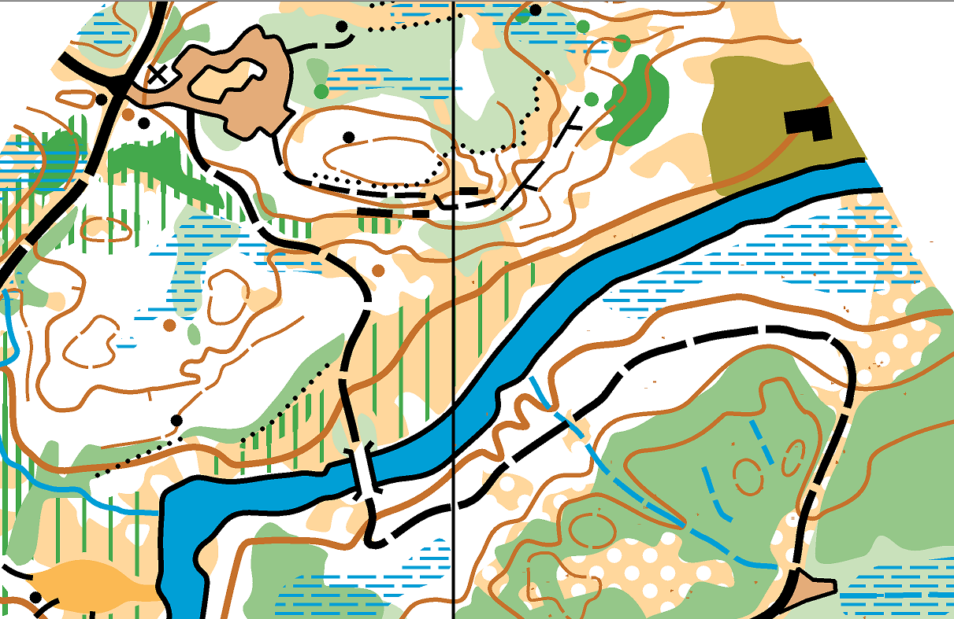
Start area
To Start

Toilets
Nearest toilets are within Aberfoyle but are unlikely to be open at this time.

The Area
Lochan Spling, part of the larger Loch Ard area, is an area of tough running and varied deciduous and coniferous forest. Notorious for its difficulty it will provide challenge to anyone, from novice to elite so please choose the appropriate course for your stage in your orienteering journey.

On offer we have a Novice, Short and Long distance course, with lengths provided below and climb provided in the final details.

Course lengths (Subject to minor change) -
Novice - 1.7km
Short - 3.7km
Long - 4.7km

It is worth noting that no matter your usual course or series points, this is Loch Ard and courses will strictly close at 8pm. Do not be afraid to move down to a shorter course if you are unsure.

Download
Download will be located at the finish BEFORE you return to your car. Please ensure you download before you leave the area.

Important Safety Announcements

Recent extensive felling has changed the landscape since the Christmas Cup and SWAT training weekend. Courses have been planned with recent felling in mind (as of mid February).

Recently felled areas are deemed unsafe at this time and marked as out of bounds on the map.

As ever, we will be sharing the space with other users so please be courteous at all times.

Deer are known to be in the area and if you startle one it may run towards other runners. Please be vigilant.

Please make sure you run with a whistle and spare head torch.

For your safety you must report to download even if you do not finish. Please respect the course closure time of 2000.

Please be vigilant for ticks.

Contact details
Liz Owen
07966 499582

Peter Owen
07379 107809

FVO number 01786 619 189

